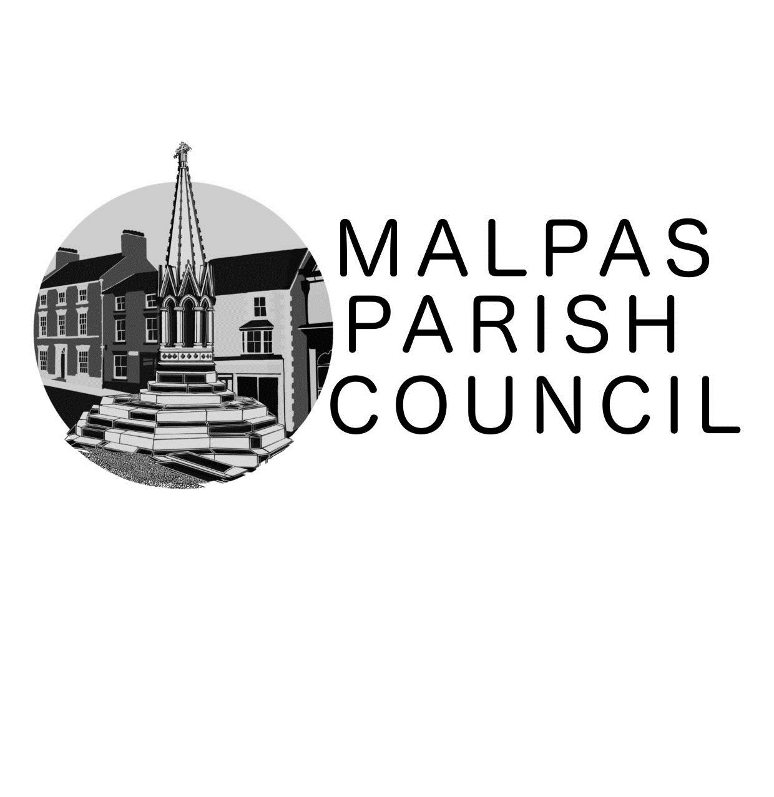

Grant Application Form & Guidelines
Applicant’s Details
Name of Organisation

Name of Contact

Address for Correspondence (inc. payments)

Contact Telephone Numbers: Day
Evening

E-mail Address

Preferred method of communication | Please indicate: letter / telephone / E-mail
Does the organisation have its own bank account? | YES / NO
Is your organisation affiliated to a National Body? | YES / NO  If YES, Please give details
Does your organisation charge a membership fee or for public for use of your facilities? | YES / NO  If YES, Please provide details of how this funding will benefit the wider community not just your membership.
Has your organisation received funding from the Parish Council in the last 12 months? | YES / NO  If YES, Please provide details
Application Details
Project Title

Amount of Money you are requesting

Is this the total amount required for the project? | YES / NO  IF NO, Please give details of other sources of money including fundraising.
Will the project result in funds being raised (e.g. will the grant provide funding for an item to be sold)? | YES / NO  IF YES, Please give details of how that money will be spent.
Please give details of the application
Including:-
- Why is it needed?
- Who it will benefit?
- How many people are likely to benefit in the Parish Council area?
- When will the project take place?
- Any details of any tendering process for items of equipment?

(if necessary continue on a separate sheet)

Grant Request for £1,000 + | Please attach a copy of the organisations accounts.

I / We certify that the details given on this application are true and correct.

SIGNED…………………………………………. DATE…………………………………………….
Please return to the clerk: Mrs. R. Shackleton, Langdale, Sarn, Malpas, Cheshire,SY14 7LN
E-mail malpaspc@hotmmail.com
Grant Guidelines
Malpas Parish Council strives to allocate grants and donations in a fair and open manner judging each application on its own merits.

When allocating grants and donations the Parish Council must show regard to the statutory powers granted to the council through various local government acts and Audit regulations. A copy of this can be found in the back of The Good Councillors Guide or from the clerk.

The Parish Council does not provide grants or donations to individuals or national charities.

All grants and donations are made on a strictly one off basis – receiving funding in one financial year does not mean funding will be automatically provided in future years.

All grants and donations given must be for the benefit of some or all of the parishioners of Malpas Parish Council. As such the Council asks all applicants to confirm how many parishioners are likely to benefit from the applications approval and where possible identify the number who will benefit.

When seeking funding from Malpas Parish Council you and your organisation should take into account the following criteria which are intended as guidelines rather than prescriptive rules:-
- Be able to provide a clear explanation of what the funding is for, including time scales.
- Be able to demonstrate how ‘value for money’ has been achieved e.g. tendering process that has been followed.
- Be able to provide examples of other funding sources including fund raising events.
- Be able to show who will benefit from this funding.
- Be able to explain what impact not receiving this funding will have on your organisation.

Groups must meet the following criteria:-
- Have an organisation bank account (not personal).
- Must provide copies of the organisations accounts if requesting £1000+ or if requested to do so.

Timing of Applications:-
Month | Action
March | Grant Application forms are to be submitted by post or email 31st March.
April | Grant applicants are invited to attend the April Parish Council meeting, if necessary, and to provide additional information and answer any questions the Parish Council may have.
May | The Parish Council will consider the grant requests as previously submitted and decide on amounts for grants for current financial year.
June | Grants are paid to organisations.

When deciding allocation of grants and donations Malpas Parish Council will consider the following criteria:-
- The benefit to the parishioners (including the number) of Malpas Parish Council in providing this funding.
- The financial circumstances of the organisation.
- How previous funding has been spent by that organisation.
- The financial position of the parish council itself.

Malpas Parish Council will not generally fund:-
- Political organisations.
- National Bodies or Charities.
- More than one grant application per year from any one organisation.
- Projects which will only benefit members of an organisation where membership is determined by a membership fee and is therefore not open to all parishioners.

It should be noted that all parish councillors are governed by the Code of Conduct and have an obligation to declare pecuniary or other interests where relevant when considering the allocation of all grants or donations.

To be considered for funding by Malpas Parish Council you can apply in writing or request an application form from the clerk.

For more information please contact the clerk:-

Mrs. R. Shackleton,
Langdale,
Sarn,
Malpas,
SY14 7LN
Tel: 01948 770678
E-mail: malpaspc@hotmail.com

